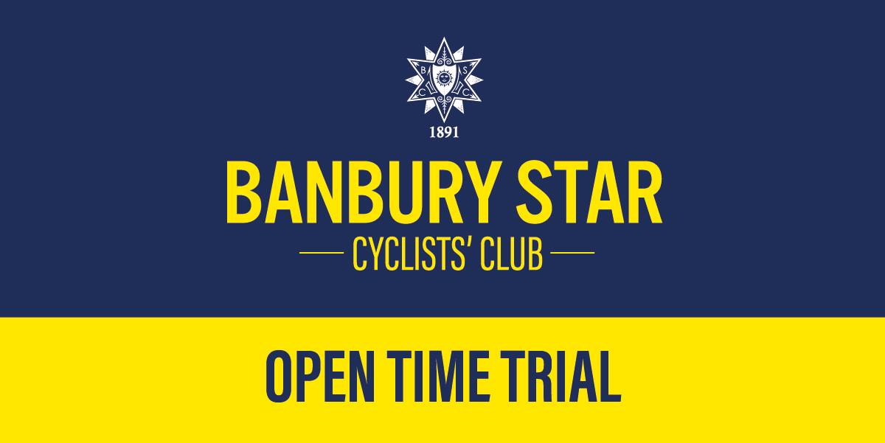
Banbury Star Cyclists’ Club Open 23 Mile “HARDRIDERS” Time Trial

RESULTS

Promoted for and on behalf of Cycling Time Trials under their Rules and Regulations

And kindly sponsored by the wonderful Hook Norton Brewery

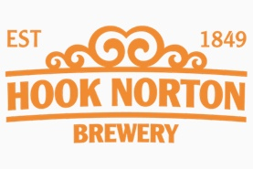

Thank you to all riders who entered this first open event of ours this year. We had forgotten quite how much work is involved, but things ran smoothly and despite the gusts there were some very good times posted.

I would again like to thank the members and friends of Banbury Star Cyclists’ Club, and especially Paul Dean, our President, whose assistance was very much appreciated by me. Our kitchen helpers, cake makers, course marshals, start line pusher, results runner and lead timekeeper also deserve great thanks for their efforts. Most spent some time in the cold and windy weather, so thank you all.

I would also like to thank our sponsors, who helped to provide a bumper selection of ‘recovery’ drinks. I’m sorry that we didn’t hand out some of those to everybody we had hoped to. You’ll just have to come back for the Open 10 later in the year!

Do please let me have any feedback from the event if you have any. I’m keen that we put on good events which riders want to come back to. Parking was certainly an issue which we have picked up and will try to find a solution for next year.

Best wishes

Oli Wright
ttsecretary@banburystar.co.uk

